GitHub + Jenkins integration project
- Pull code from a Git repository.
- Copy an index.html file from the repo.
- Display that HTML file using Jenkins' HTML Publisher Plugin.
- Created new job name – git demo1 – freestyle project.
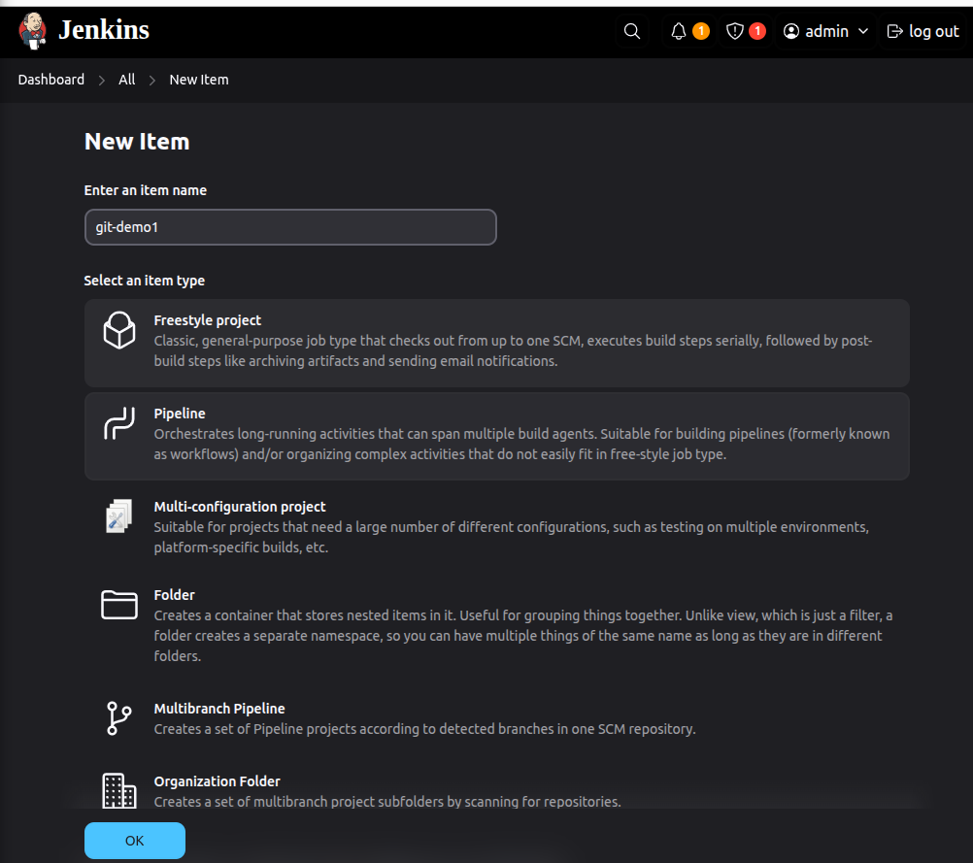

- connected git repository

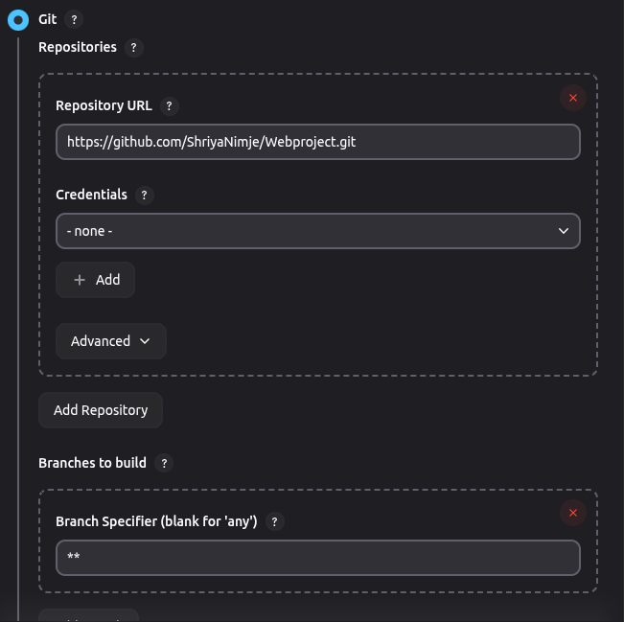

- Installed HTML Publisher Plugin

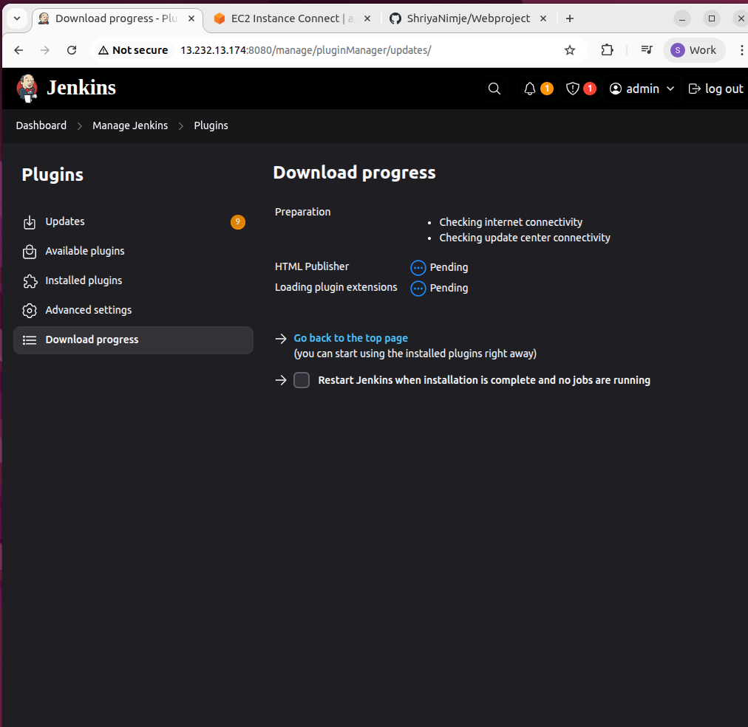

- Add Build Step to Copy HTML

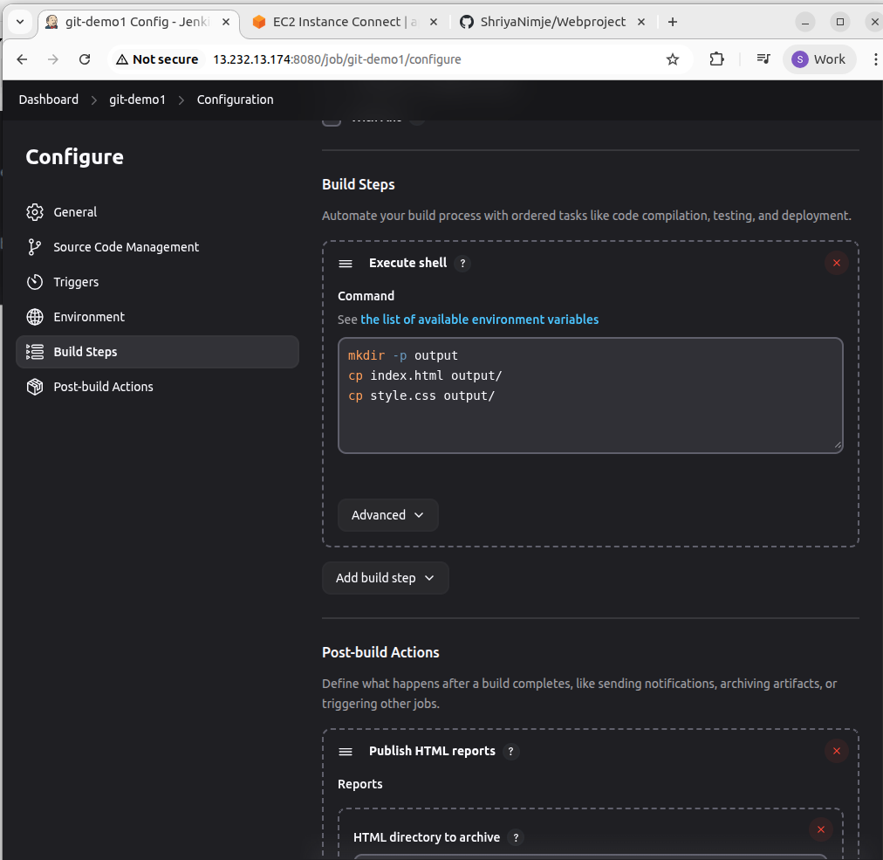

- Configure HTML Publisher – Post-build Action
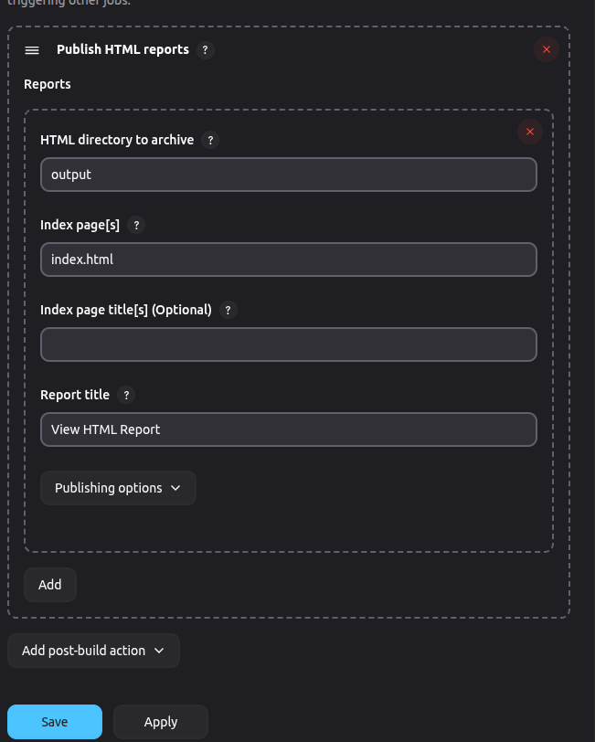

- Build and View HTML Report
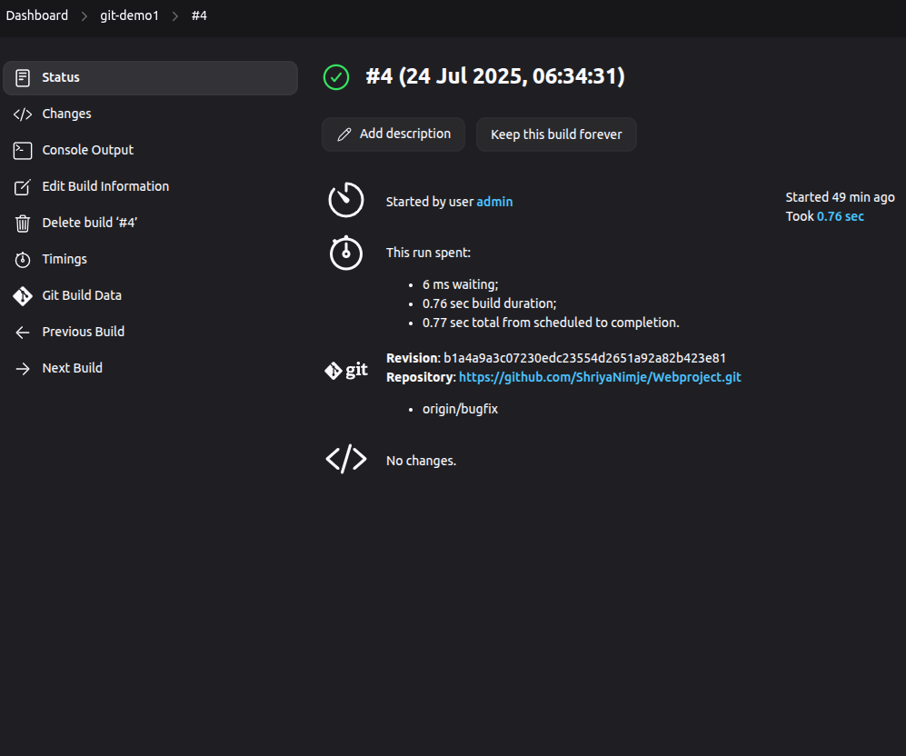

- View HTML report

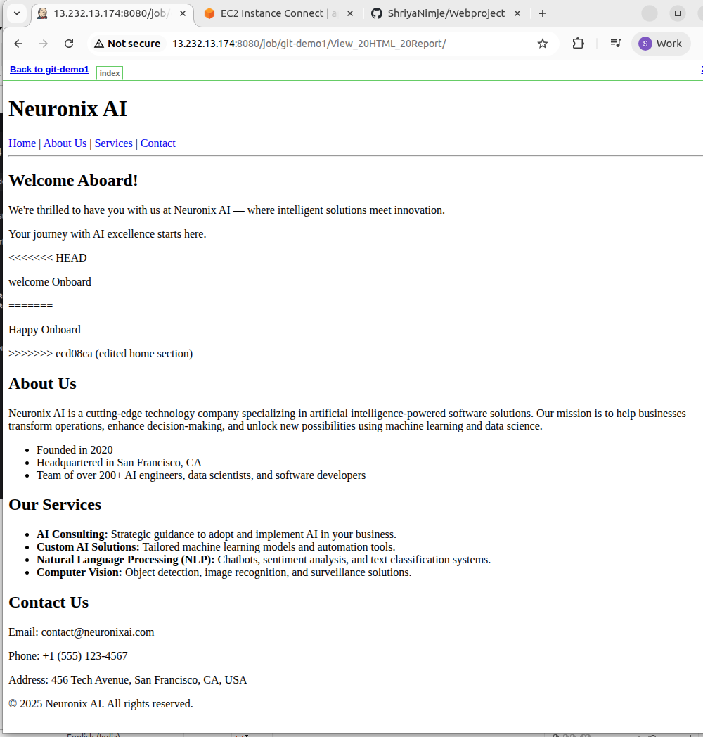

Jenkins pipeline with test reports

- Creating new project – maven-demo
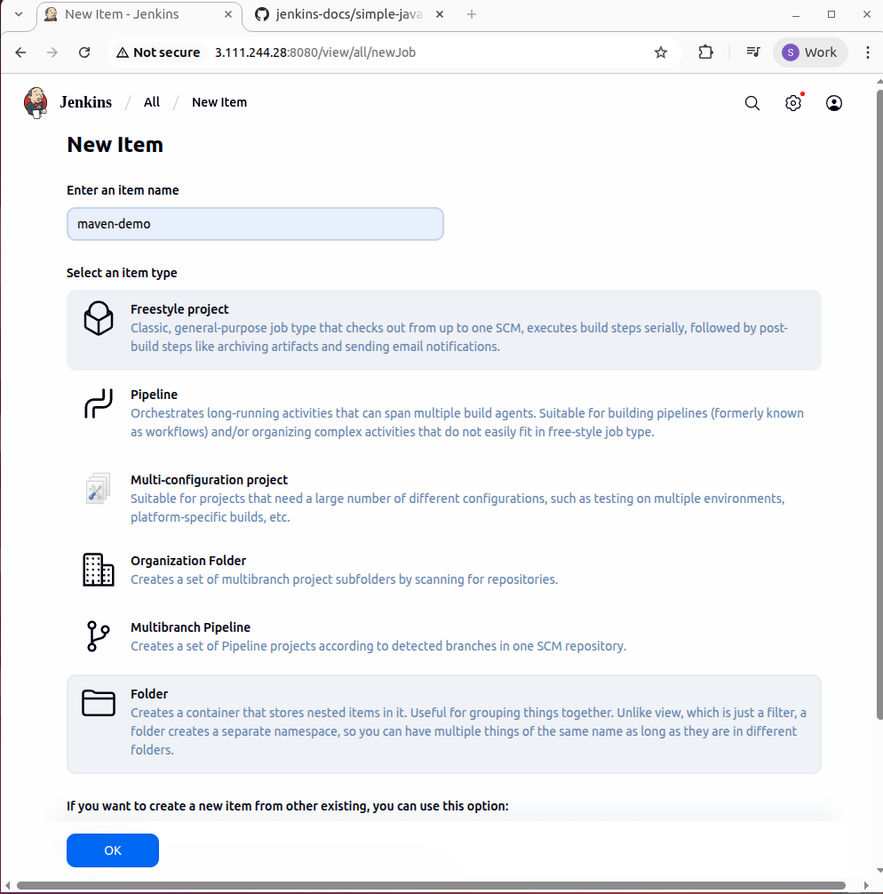

- connected git repository

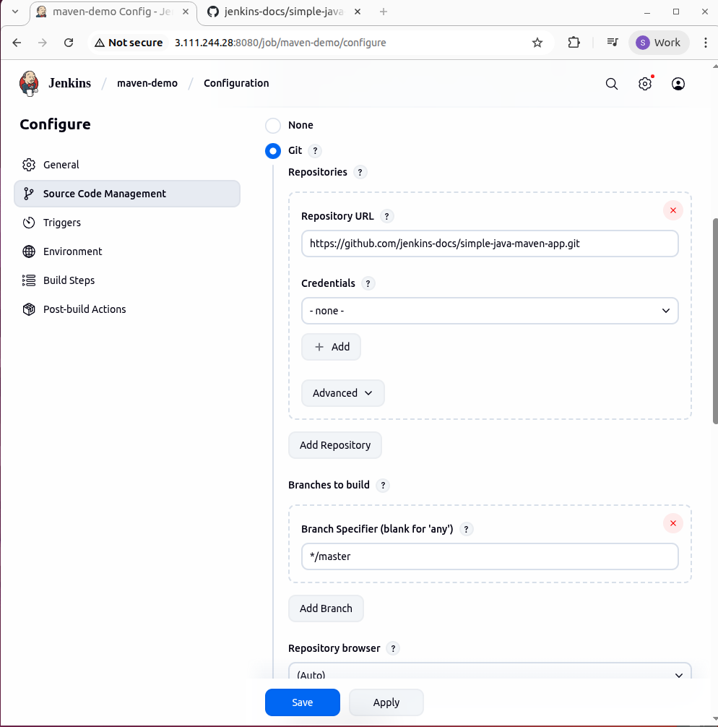

- first build

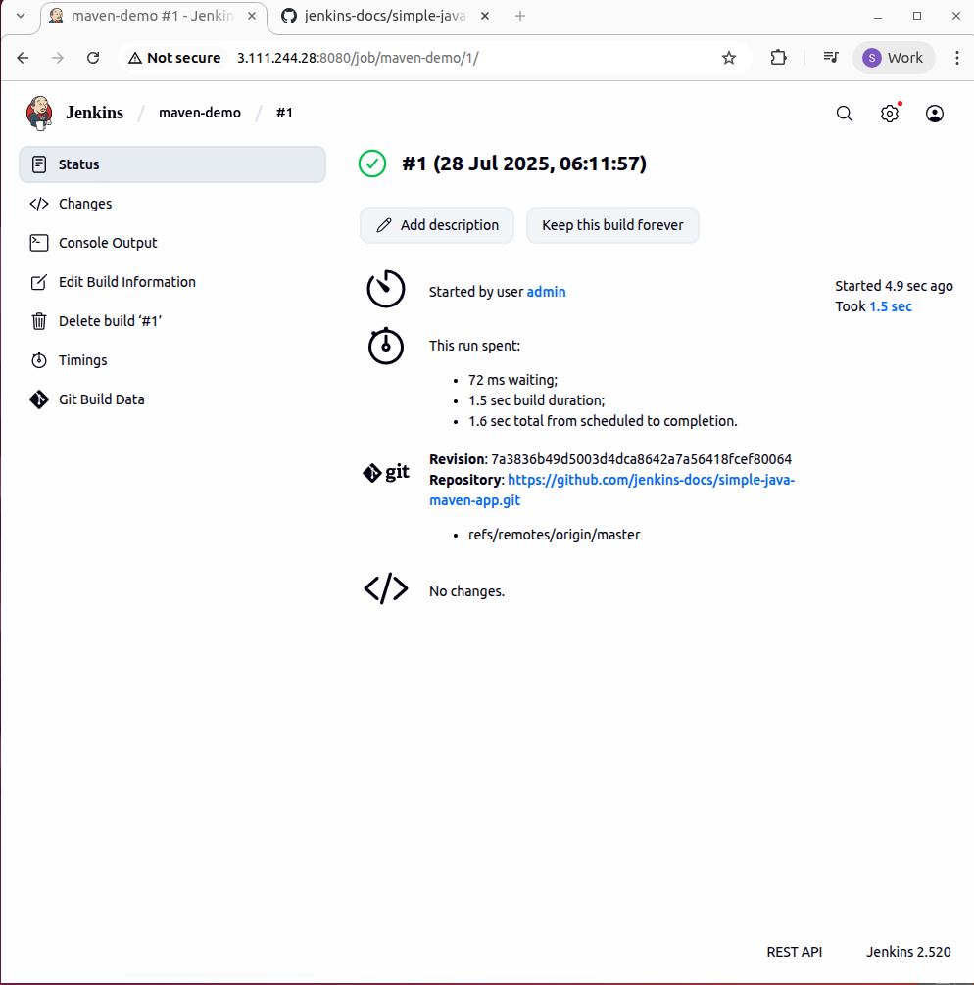

- Installing maven
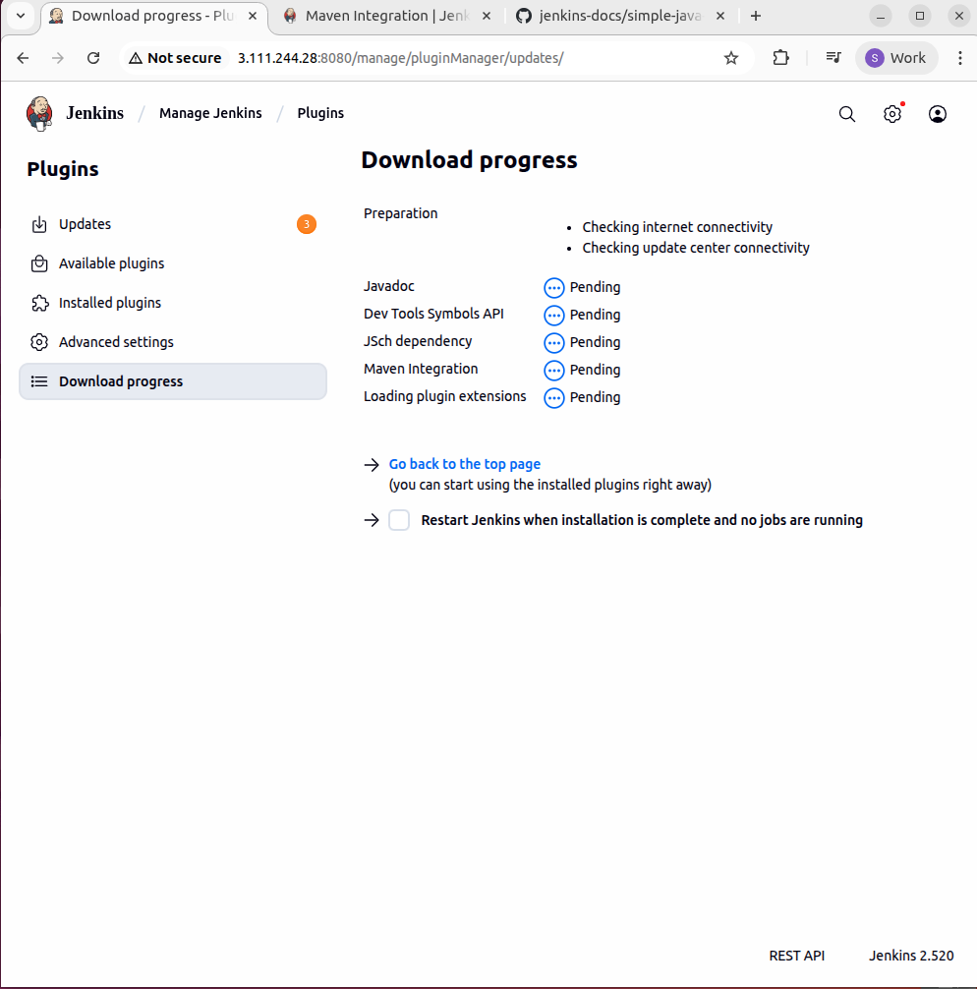

- need to specify which version of Maven we want to use.

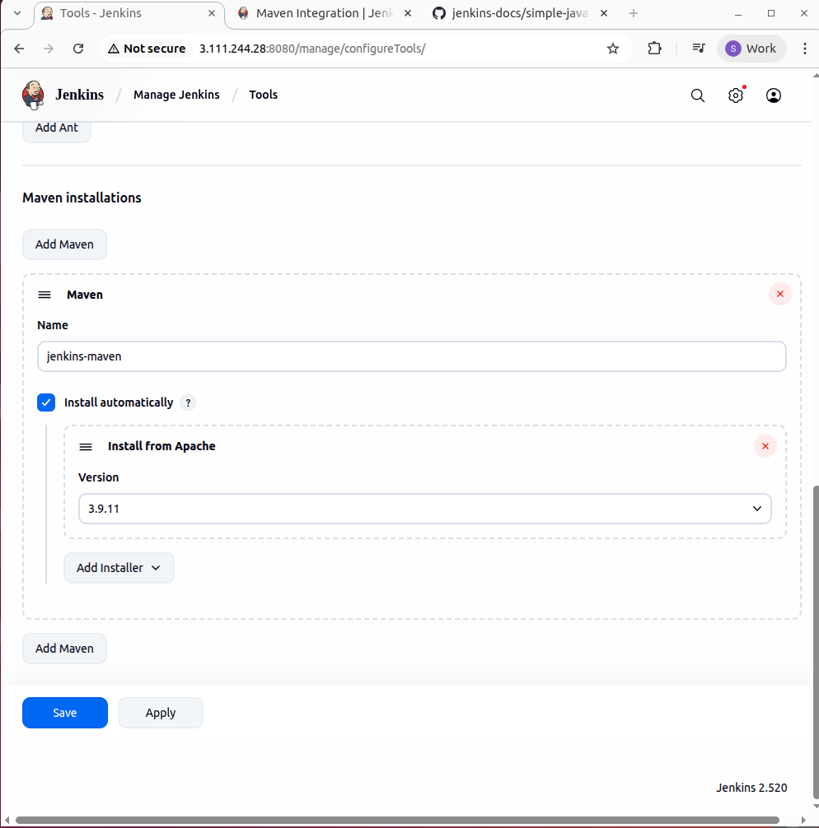

- adding build steps

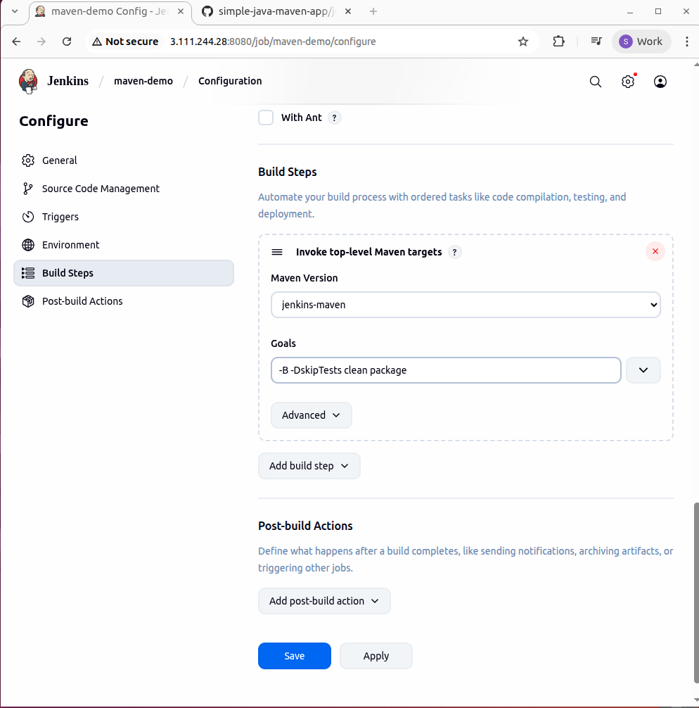

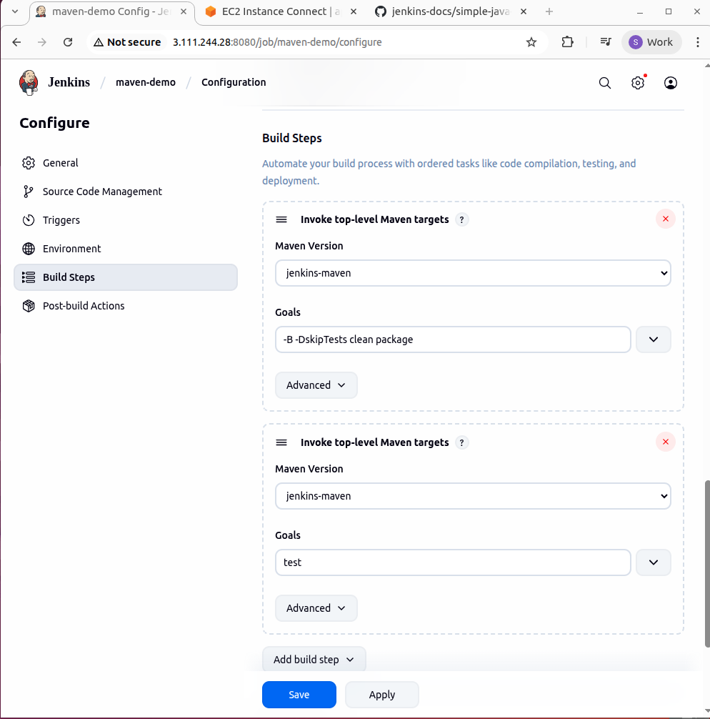

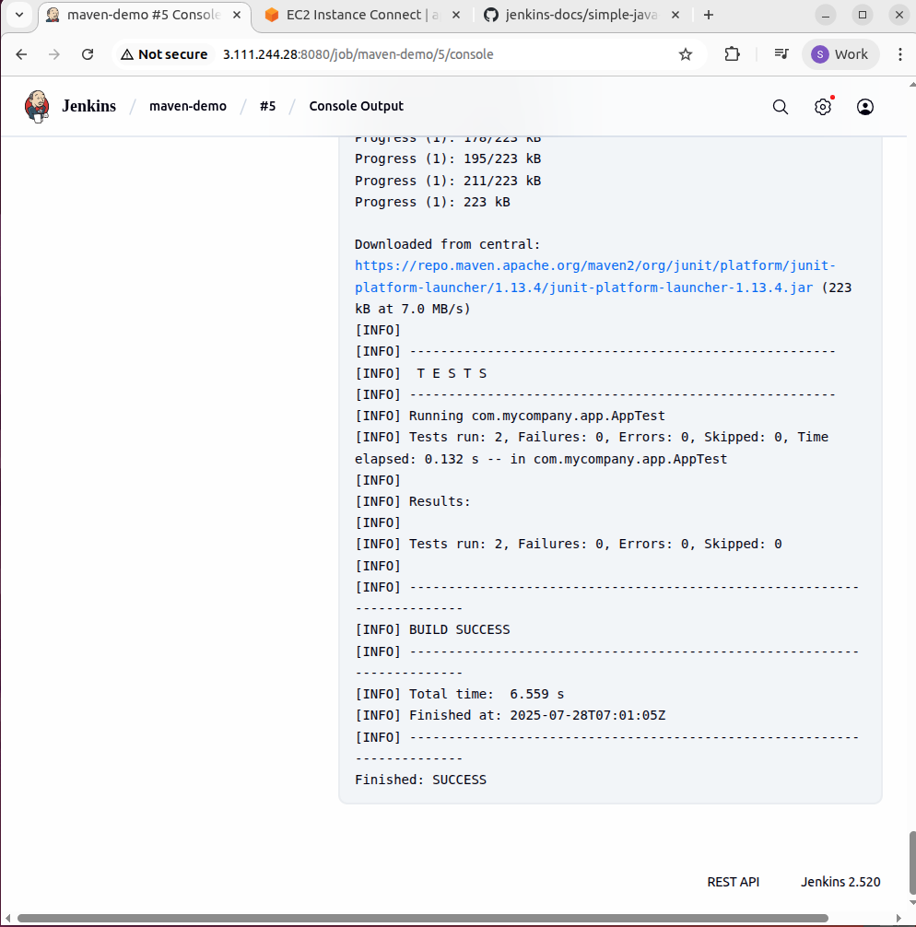

- Build Status of Test Cases

- running unit tests with Maven and then deploying the built application by executing its JAR file

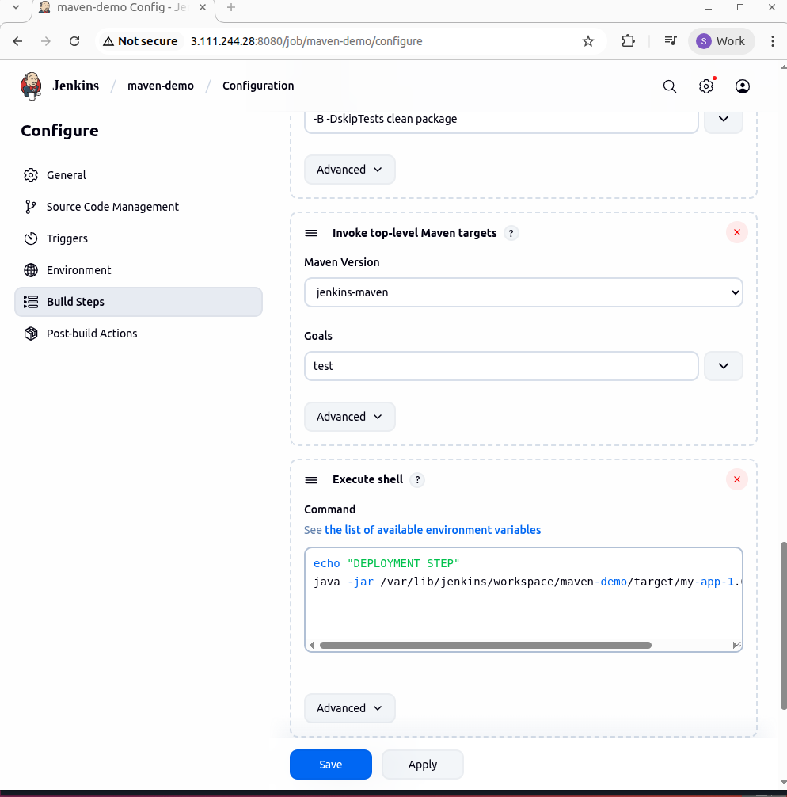

- Publishing graphical reports

